**Gandharan Avatars Generated Using Mutli Agent Pipeline**

**Given Prompt**

Gandharan warrior, realistic avatar.

**Extended Prompt**

Create a highly detailed and realistic avatar of a Gandharan warrior, emphasizing intricate musculature and dynamic poses characteristic of Gandharan art. The warrior should be depicted in an action pose, wearing ornate armor that reflects a blend of local and Hellenistic designs, featuring elements such as a helmet with decorative motifs and a breastplate showing fine craftsmanship.

Incorporate weapons typical of the era, such as a curved sword and a shield adorned with intricate carvings that signify strength and protectiveness. The avatar's expression should convey bravery and determination, capturing the spiritual significance associated with warriors in Buddhist narratives.

Use a color palette that reflects the earthy tones of schist and limestone, imbuing the armor with textures that suggest light interplay. The depiction should include cultural attributes that resonate with the Buddhist theme, perhaps showing the warrior alongside symbols of dharma or protected relics. Ensure the overall composition reflects the rich cultural legacy of the Gandhara civilization and its artistic values, highlighting not just the physicality of the figure but also its connection to Buddhist iconography and the historical significance of the warrior's role as a protector of dharma."

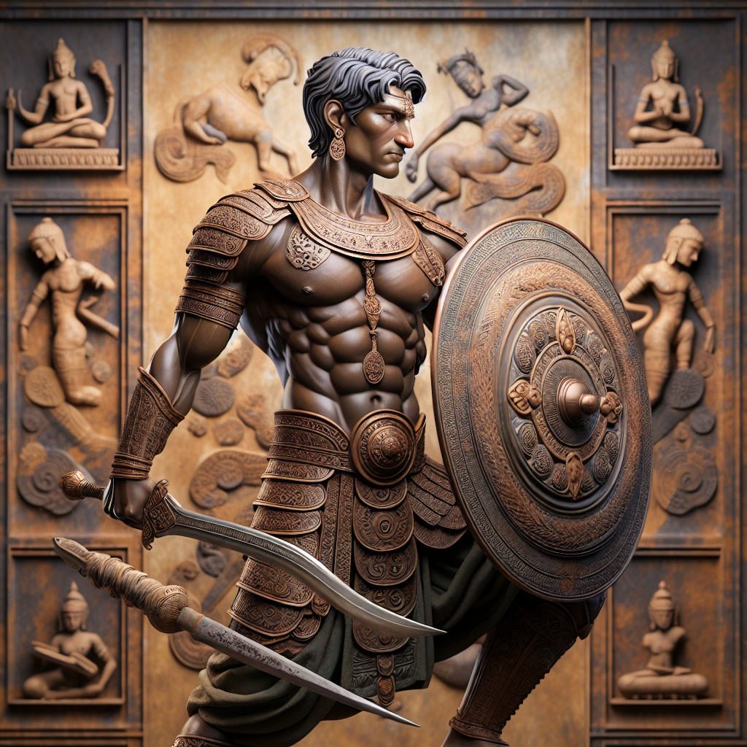**Generated Image**

**Character Backstory**

The warrior, known as Akar, was born in the vibrant city of Taxila, the heart of the Gandhara civilization, around 170 CE. Son of a revered sculptor, Akar grew up among the masterpieces of art that adorned the stupas and monastic complexes dotting the landscape. His father imbued in him a passion for the arts, but Akar's heart leaned towards the call of valor and the dharma he had learned from the teachings of Buddhism.

As a youth, Akar was mesmerized by tales of the Buddha’s past lives, recounting not just supernatural ascensions but also earthly battles against ignorance and evil. His training began early; he was tutored in martial skills by the seasoned warriors who protected the sacred relics of the stupas. It wasn’t long before he became a formidable figure, his physique sculpted from rigorous training, reminiscent of the very statues he admired. Muscles rippling, he wore armor that blended local craftsmanship with Hellenistic designs, embodying the rich cultural exchanges that marked his nation.

Akar fought bravely in various skirmishes against marauding tribes threatening the sanctity of their land. Dressed in ornate armor, decorated with motifs symbolizing protection and strength, he wielded a beautifully curved sword—a family heirloom—as well as a shield that bore intricate carvings of celestial beings. His expression was one of determination and bravery, channeling the energy of the Bodhisattvas he aspired to emulate.

In the quiet moments after battle, Akar often found solace by the stupas, engaging in meditation to reflect on the balance between the warrior’s path and the teachings of compassion. He understood that the true essence of being a protector was not solely in physical strength but in upholding the values of peace and enlightenment. Akar thus became a living embodiment of Gandharan artistry and spirituality, a warrior not just in combat, but in the unwavering pursuit of wisdom and truth that resonates with the soul of his ancestors.

**Given Prompt**

Gandharan Women

**Extended Prompt**

Create a highly detailed artwork depicting a Gandharan woman from the 6th century BCE. The character should embody the unique fusion of Greco-Buddhist aesthetics characteristic of the Gandhara civilization. The woman is adorned in flowing robes rich in texture and drapery, reminiscent of Greco-Roman styles, with intricate patterns that reflect local craftsmanship. Accentuate her outfit with lavish jewelry, such as large earrings and layered necklaces, representing her social status and beauty. She should have an elaborate hairstyle, possibly with braids or decorative pins, showcasing the artistic conventions of the time. Position her in a graceful yet commanding pose, perhaps with an inviting smile that reflects spiritual wisdom. Her demeanor should convey a sense of dignity and strength, highlighting her role within both the domestic and religious spheres. Although the focus should be primarily on the woman, subtle hints of her environment such as decorative elements that represent household artifacts or symbols of spirituality could be included. The artwork should combine realism with the characteristics of Gandharan art highly refined details, vivid representation of textiles, and a warm color palette that reflects the historical context. Incorporate elements that suggest her participation in religious life, such as a small depiction of a bodhisattva or floral motifs nearby, emphasizing her connection to spirituality. Overall, the composition should reflect the cultural syncretism of the Gandhara civilization, celebrating both local traditions and foreign influences in a culturally rich and engaging portrayal.

**Generated Image**

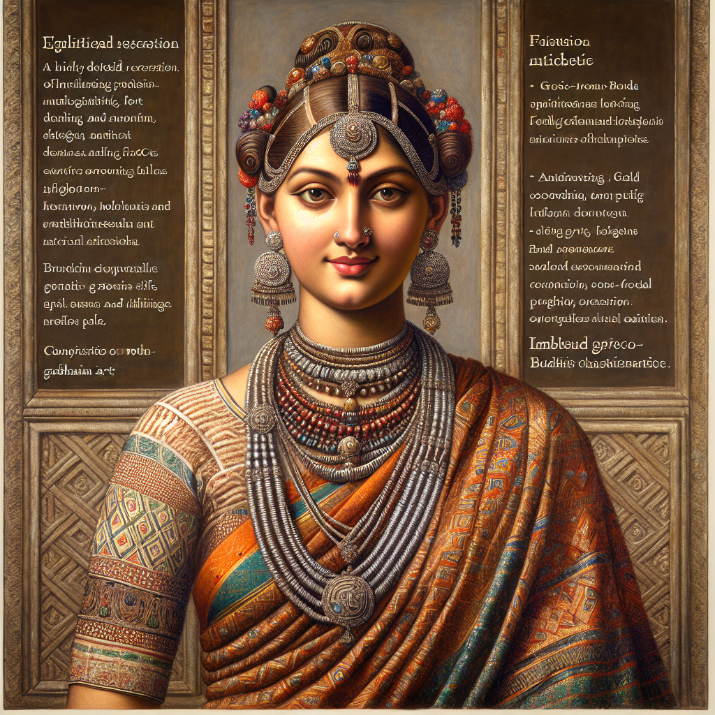

**Character Backstory**

In the heart of Gandhara, during the 4th century BCE, a woman named Anaya emerged as a symbol of the fusion between spiritual devotion and the artistic expression of her time. Born into a family of skilled artisans, Anaya was surrounded by the vibrant world of sculpture and textiles, her childhood filled with the rhythmic sounds of chisel against stone and the soft whisper of fabric as her mother wove intricate patterns into beautiful garments.

Anaya's beauty was celebrated not just for her physical grace—her long, flowing robes made of the finest silk, adorned with delicate embroidery—but also for her profound wisdom. She inherited her father's gift for art, creating terracotta figurines that depicted the divine feminine, reflective of Avalokiteshvara’s mercy. Each piece she made was infused with her belief in compassion, drawing admiration from neighbors and traders along the bustling Silk Road.

As a young woman, she became a prominent figure in her community, often seen participating in rituals honoring the bodhisattvas. Her presence brought an aura of tranquility, inspiring those around her to delve deeper into their spirituality. Despite societal pressures, Anaya actively engaged in discourse about women’s roles in both domestic and public spheres. She encouraged her peers to contribute artistically to the religious practices, believing that women’s creative expressions were vital to the vibrancy of their culture.

Yet, Anaya's journey was not without challenges. A devastating drought threatened her village's resources, forcing her to rally the women around her. Together, they organized efforts to sustain their families, establishing communal gardens and sharing the bounty. This resilience solidified Anaya’s leadership, earning her the title of “Mother of the Fields.”

Generations later, Anaya would be immortalized in the sculptures that arose from the Gandharan workshops, her likeness captured in the intricate details of her attire and the strength reflected in her expression. She became a timeless representation of the ideal Gandharan woman—beauty intertwined with strength and creativity, embodying the depth of cultural syncretism that marked her civilization. Even as the sands of time shifted, Anaya’s spirit lived on in the art that decorated temples and homes, a gentle reminder of the powerful legacy of women in Gandhara.

**Given Prompt**

“Gandharan ascetic monk with a shaved head, serene expression, ornate textured robes, lotus & Dharma‑wheel accents, soft diffused light.”

**Extended Prompt**

Create a portrait of a Gandharan ascetic monk embodying serenity and spiritual wisdom. The monk should have a shaved head symbolizing renunciation and enlightenment, with a serene expression reflecting deep meditation and inner peace. He is adorned in intricately detailed robes that exhibit the high craftsmanship of Gandharan artisans, featuring elaborate patterns and textures indicative of the rich textile traditions of the era. The robes should flow gracefully around him, capturing the essence of the spiritual and aesthetic values of the time. In one hand, the monk holds a delicate lotus flower, symbolizing purity of body, speech, and mind. The lotus should be rendered with subtle hues that reflect its significance. Incorporate a Dharma wheel in the background, softly illuminated, to signify the teachings of Buddha and the path towards enlightenment. Utilize soft, diffused lighting to create an ethereal atmosphere, enhancing the tranquil presence of the monk. The light should evoke the calming nature of serene environments, aligning with the contemplative themes of Buddhist philosophy. The focus should be solely on the monk, capturing his essence in a way that conveys the rich cultural tapestry of the Gandhara civilization. Ensure the overall tone of the image is peaceful, inviting viewers into a moment of reflection and calmness.

**Generated Picture**

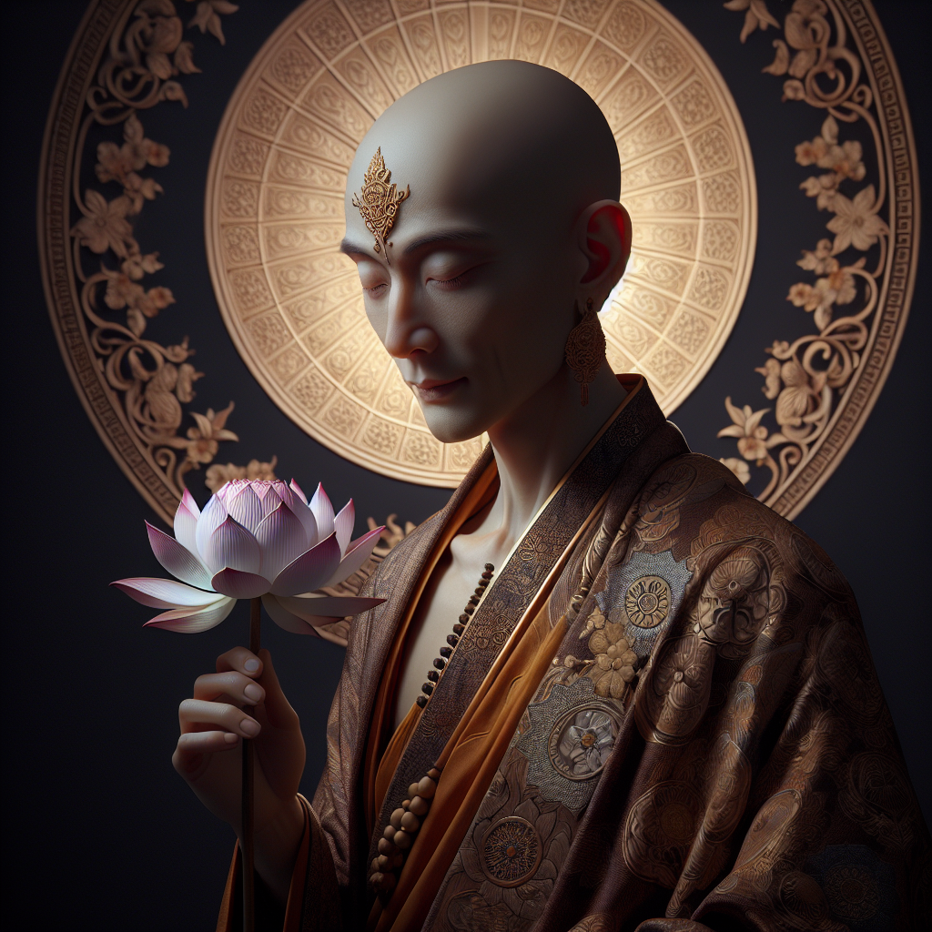

**Backstory**

In the heart of the Gandhara civilization, amidst the thrumming life of bustling trade routes and the quietude of rugged mountains, there lived an ascetic monk named Ananda. Born into a humble family of silk weavers, Ananda was a quiet child with an innate curiosity about the world around him. His days were often spent wandering the serene banks of the Indus River, where the early morning mists rose like ethereal veils, and the vibrant hues of lotus flowers painted the waters in tones of blush and gold.

At the tender age of fourteen, grief struck when Ananda's beloved younger sister succumbed to illness. This tragedy became a pivotal moment in his life, igniting a profound quest for understanding the causes of suffering. Fueled by heartache yet enveloped in compassion, he renounced worldly attachments and ventured into the mountains. Under the guidance of wise masters, he learned the teachings of the Buddha, experiencing moments of deep meditation that unveiled glimpses of enlightenment.

With each passing year, Ananda's spirit grew indomitable, embodying serenity amid life's tempest. He adorned himself with intricately woven robes that shimmered like the stories of his ancestors, each stitch a testament to Gandhara's rich textile traditions. He carried a delicate lotus flower—a reminder of purity and spiritual growth—while a Dharma wheel accentuated his unwavering commitment to the Buddha's path.

Soft diffused light illuminated his surroundings, as if nature itself sanctioned his journey. Through artful carvings and the rich traditions of Gandharan artisans, he began sharing his insights with villagers, teaching them that peace lies within, even amidst chaos. Ananda became a beacon of hope—a figure who transformed sorrow into profound wisdom, guiding others to cultivate their own inner tranquility. Ultimately, his legacy became interwoven with the very fabric of Gandhara, inspiring generations to embrace the serene path toward enlightenment.

**Given Prompt**

“Gandharan yogi with a braided topknot, calm contemplative gaze, flowing saffron‑textured cloak, realist avatar.”

**Extended Prompt**

Create a digital avatar inspired by the Gandhara civilization depicting a yogi. The yogi should have a calm, contemplative expression, merging Indian and Hellenistic facial features, reflecting serenity and deep reflection. He is dressed in a flowing saffron-colored cloak that appears lightweight with intricate textures, symbolizing renunciation and meditation. His hair is styled into a braided topknot, representing dedication and purity. He should be portrayed in a traditional meditative pose, sitting cross-legged with hands on his knees, palms facing upward. The background should have a subtle gradient evoking ancient stone aesthetics, enhancing the overall composition without taking focus from the yogi. Aim for high detail in the anatomical features and engravings in the cloak, exuding calmness, wisdom and connecting to the rich artistic legacy of Gandhara.

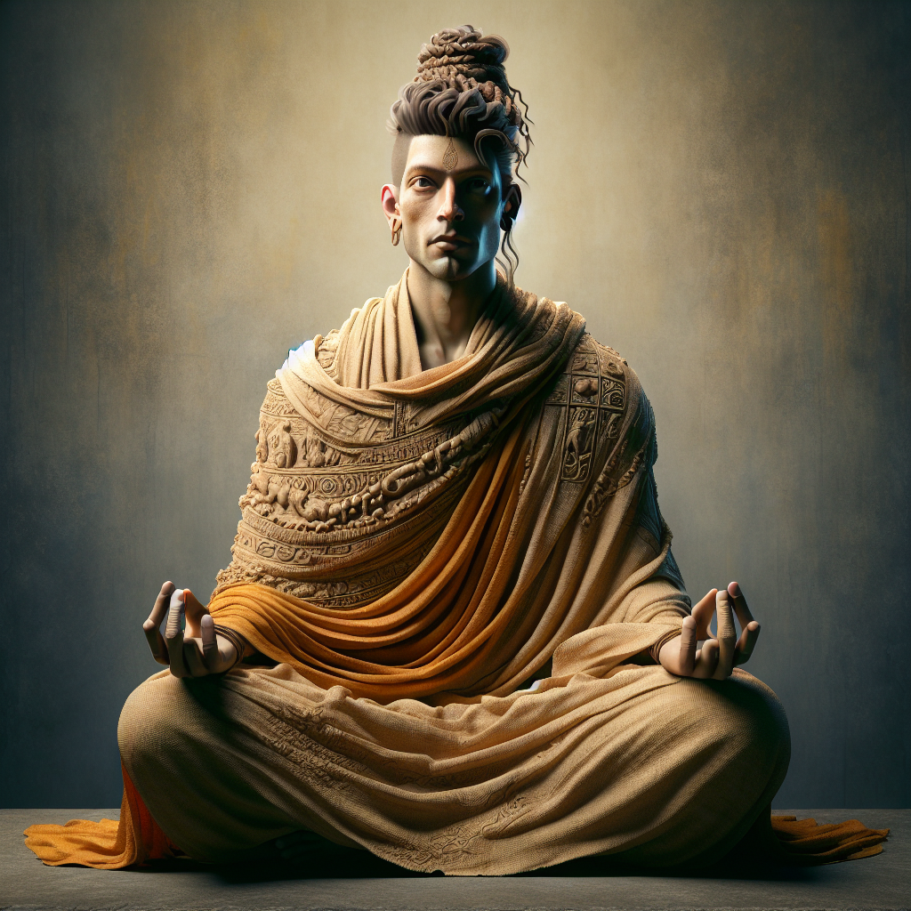**Generated Picture**

**Backstory**

In the heart of the flourishing Gandhara civilization, amidst the intricate interplay of Indian, Hellenistic, and Persian cultures, lived a yogi named Arvind. Born during the height of the Kushan Empire in the 2nd century CE, Arvind was the son of a humble artisan known for his mastery in sculpting serene representations of the Buddha. From a young age, he was immersed in the enchanting world of art and spirituality, often wandering through bustling markets filled with ornate sculptures and intricate carvings.

As a child, Arvind was captivated by the stories of ascetics who sought enlightenment. He spent hours in meditation, striving to connect with the divine. His father, inspired by the blend of cultures around him, fashioned a saffron cloak for Arvind, symbolizing both Buddhist renunciation and the humility of the wandering monk. This cloak would become emblematic of his identity, worn as he traversed the foothills of the Himalayas, seeking wisdom and understanding.

Years later, a profound experience during meditation led Arvind to a serene realization of inner peace and compassion, embodying the ideals of Gandharan art. His calm, contemplative gaze reflected the teachings he absorbed from the ancient scrolls found in the monasteries where he studied. Arvind grew into a symbol of tranquility, his braided topknot a testament to his dedication and purity.

Arvind became known as the "Yogi of Compassion," teaching villagers the importance of meditation and selflessness. His teachings echoed throughout the region, inspiring numerous followers and enriching their lives with a peaceful philosophy. Even long after his passing, stories of his serene visage and transformative practices continued to inspire generations, encapsulating the essence of the Gandhara civilization's rich spiritual tapestry, an enduring legacy of serenity in a world of chaos.

**Given Prompt**

“Greco Buddhist maiden with straight shoulder length hair, gentle smile, layered drapery robes, realistic avatar.”

**Extended Prompt**

Create a realistic avatar inspired by the Greco-Buddhist maiden of the Gandhara civilization. The maiden should have straight, shoulder-length hair styled simply to emphasize natural beauty, possibly adorned with a delicate diadem. Her features should present a harmonious blend of South Asian and Greek characteristics, with a gentle smile conveying peace and serenity. Design her wearing layered draped robes reminiscent of Greco-Roman togas, showcasing fine detailing of the fabric's folds and textures. The avatar should emanate grace, embodying spiritual beauty and humility, reflecting both Buddhist and Greco-Roman aesthetics, symbolizing a cultural bridge between the two. Set against a neutral background.

**Generated Picture**

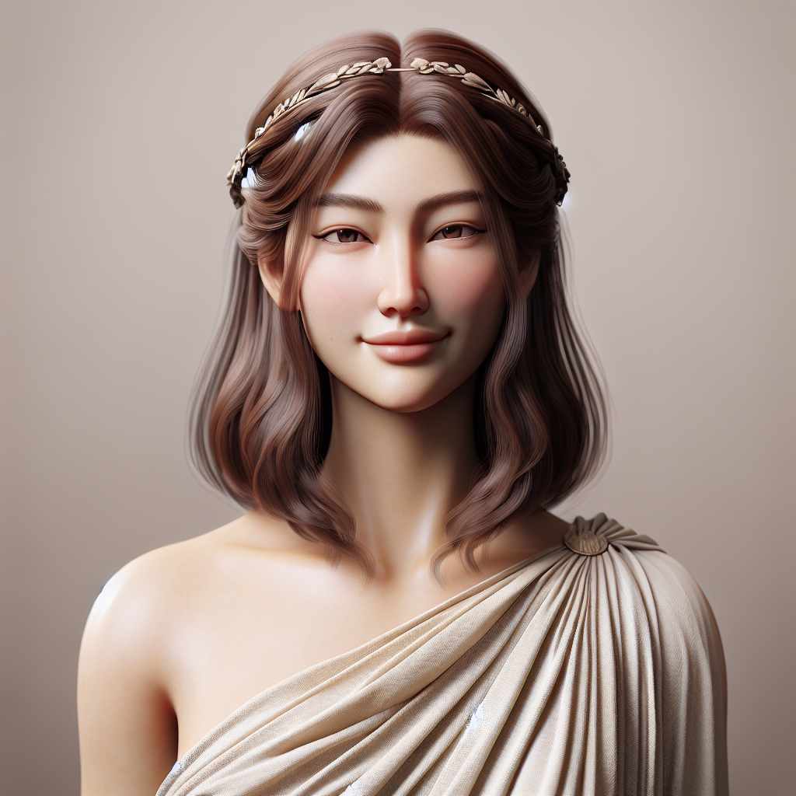

**Backstory**

In the heart of the ancient Gandhara civilization, amidst bustling trade routes and vibrant cultural exchanges, there was a maiden named Lila. Born to a family of skilled artisans, her father carved exquisite statues of the Buddha, while her mother wove rich fabrics, melding colors that spoke of the skies at dawn. Such artistry flourished under the sun-kissed hills, where Greek influences mingled with Eastern traditions to shape a unique cultural identity.

Lila's beauty reflected this fusion—a cascade of straight, shoulder-length hair adorned with a delicate diadem that glimmered like the stars above. She often wandered through markets filled with spices, silks, and philosophies, her gentle smile earning the affection of many. It was not merely her looks, but the serenity she radiated that drew others closer. Her expression, marked by warmth and kindness, mirrored the tranquil ethos of Buddhism that was blooming in her society.

Draped in elegantly layered robes that spoke of both Greek and Indian styles, she embodied grace and status. The intricate details of her attire, each fold telling tales of devotion and artistry, represented the harmonious beauty revered in Gandharan art. Lila took pride in being a cultural bridge, narrating through her presence the story of her land where ideas danced between traders and travelers, ancient philosophies fused, and religions blossomed.

Driven by an insatiable curiosity about the world beyond her homeland, Lila often dreamt of exploring vast destinies. Yet, she understood that her true calling lay in nurturing the beauty of unity, of weaving together the threads of cultures through compassion and artistry. Thus, she became not only a symbol of grace in her time but a beacon of luminous hope—an embodiment of timeless wisdom that would echo through generations, representing the enduring legacy of the Gandhara civilization.

**Given Prompt**

“Gandharan bodhisattva with hair in a neat bun, subtle halo, draped robes, Dharma‑wheel motif, soft side‑lighting, hyper‑realistic avatar.”

**Extended Prompt**

Create a hyper-realistic avatar of a Gandharan bodhisattva, focusing on the figure rather than the environment. The bodhisattva should be depicted in a serene and compassionate pose, conveying grace and benevolence. The face should have soft, gentle features, reflecting wisdom and kindness. The hair should be styled in a neat bun, typified as an 'ushnisha'. Include a soft halo surrounding the head, representing the spiritual radiance of the bodhisattva. The bodhisattva should be adorned in intricately detailed flowing robes that combine Indian and Graeco-Roman styles. The Dharma wheel, symbolizing the teachings of the Buddha, can be subtly integrated into the composition. Use soft side lighting to enhance the three-dimensional quality, emphasizing the contours of the face and the flowing robes.

**Generated Picture**

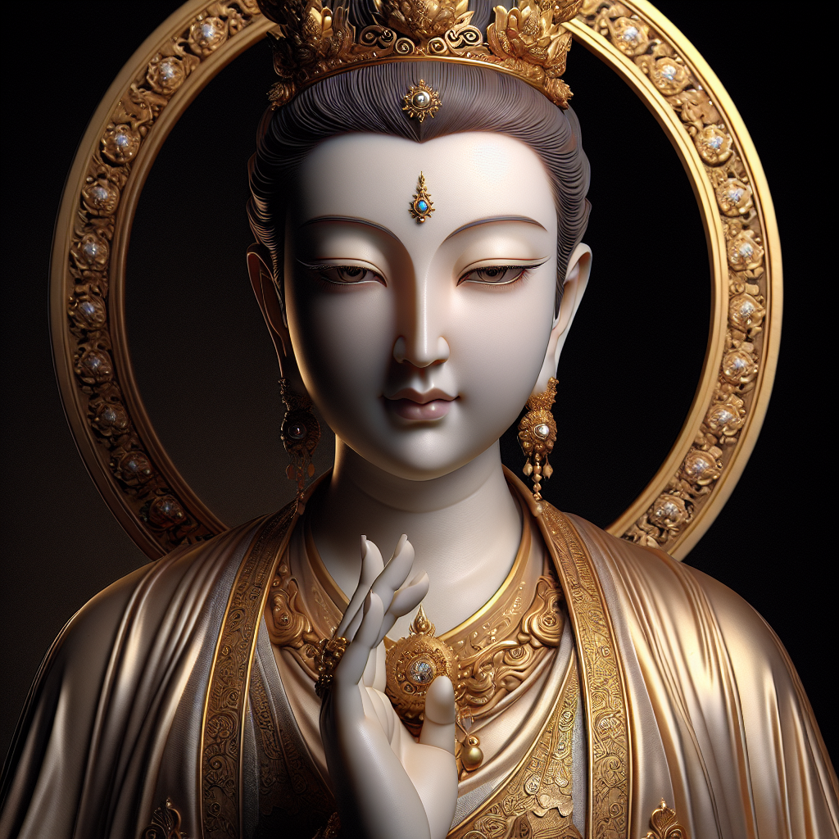

**Backstory**

In the heart of the bustling markets of ancient Gandhara, where the aromas of exotic spices mingled with the sound of distant melodies, lived a bodhisattva named Arjuna. Born into a family of artisans, his early life was steeped in the rich traditions of his civilization, known for its unparalleled artistry that blended Indian, Hellenistic, and Central Asian influences. From an early age, Arjuna was captivated by stories of enlightenment, the struggles of mortals, and the boundless compassion of the Buddha.

Adorned with hair styled in a meticulously crafted bun, the 'ushnisha' signified both his noble lineage and a wisdom beyond his years. His serene presence was instantly recognizable, with gentle features that radiated kindness and warmth. Villagers from all walks of life would travel far and wide to seek the counsel of Arjuna, drawn by the subtle halo that enveloped him, a divine aura that hinted at his enlightened nature.

Arjuna's robes flowed gracefully as he moved, blending elegant Indian drapery with subtle hints of Greco-Roman inspiration. Each thread of his garments was woven with purpose, symbolizing the unity of cultures within his homeland. It was said that he could evoke the essence of the Dharma Wheel through his teachings, gently guiding souls with the wisdom of the Buddha, illuminating their paths with ancient truths.

Inspired by his encounters with those trapped in suffering, Arjuna chose to remain in the cycle of rebirth, embracing his role as a comforting guide. He recognized that true enlightenment was not just for oneself; it was a collective journey towards compassion and understanding. His laughter echoed through the valleys, while soft side lighting from the setting sun highlighted the contours of his face, rendering him an ethereal vision against the backdrop of history.

Thus, the tales of Arjuna, the Gandharan bodhisattva, were passed down through generations, etched into the very essence of Gandhara’s artistic legacy—a timeless testament to the power of love, wisdom, and the unbreakable bond that unites all beings in their quest for liberation.

**Given Prompt**

“Gandharan female monk, braided curly hair, gentle smile, layered drapery robes, realistic avatar.”

**Extended Prompt**

Create a detailed and lifelike avatar of a female monk inspired by Gandharan art, showcasing the rich cultural tapestry of the ancient Gandhara civilization. The monk has realistic features with braided curly hair cascading down, reflecting traditional hairstyles of the time, complemented by a gentle, compassionate smile that embodies the Buddhist ideals of inner peace and kindness. She wears intricately layered drapery robes characterized by detailed folds and textures, emphasizing the weight and movement of the fabric. The robes showcase a blend of Hellenistic and local styles, featuring ornate patterns and a naturalistic fit that contours to the body. The facial expression exudes serenity and empathy, with soft, expressive eyes and a warm smile, inviting viewers to connect with the spirituality and virtues represented by the figure. The style captures the realistic representation typical of Gandharan sculptures, focusing on the fine detailing of facial features, hair, and attire. The overall mood resonates with themes of compassion, wisdom, and tranquility, serving as a visual homage to the role of female monks in Buddhist communities of ancient Gandhara.

**Generated Picture**

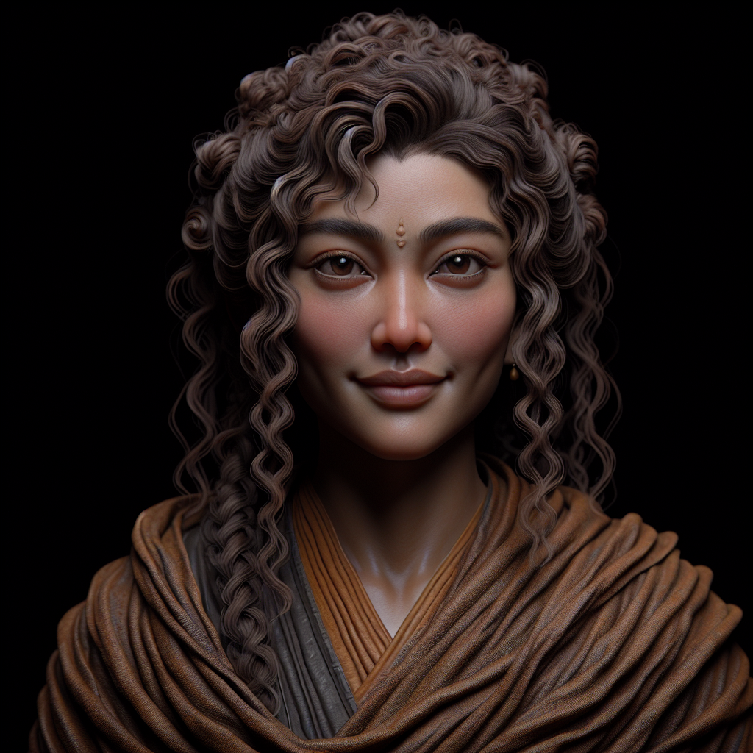

**Backstory**

In the heart of the Gandhara civilization, where the convergence of trade routes shaped a unique culture, lived a compassionate monk named Aditi. Born to a humble family in a bustling marketplace, she grew up surrounded by a vivid tapestry of colors, sounds, and cultures. Her curly hair was often braided by her mother, a tradition that connected her to the women of her lineage, their smiles radiant as they passed down stories of strength and resilience.

From an early age, Aditi exhibited a profound curiosity about spirituality, drawn not just to the physical beauty surrounding her, but to the deeper philosophy woven into everyday life. As she wandered the ancient city bustling with merchants from distant lands, she witnessed kindness exchanged in simple gestures—a mother caring for her child, a merchant sharing bread with a traveler in need. These scenarios impressed upon her the Buddhist teachings of compassion and wisdom.

Determined to embrace a life dedicated to these virtues, Aditi sought guidance from a revered female monk, an uncommon role in her culture, who became her mentor. Under her tutelage, Aditi honed her meditation practice and immersed herself in the art of drapery, learning to create complex garments that flowed with the essence of spirituality. Each layer she crafted echoed the ideals she cherished, symbolizing the intricate connections between the physical and spiritual worlds.

As she gradually became a monk herself, her presence transformed into a beacon of comfort for others. Her gentle smile, emblematic of serenity, not only resonated with her fellow monks but also offered solace to those burdened by life's trials. Aditi roamed the sacred paths of Gandhara, where her compassionate demeanor and striking representations of the female experience in sculptural art came to life.

Thus, Aditi became a symbol of the Gandharan spirit—a figure whom time would not forget, a monk whose braided hair lifted in the breeze symbolized both tradition and a blossoming future for women in Buddhism, all painted in the rich hues of her world that embraced diversity and unity.